2.7 Lab: Set up the Use of Python Within the Kali Linux Virtual Machine

Step1: Power On oof the Kali Linux Virtual Machine Environment
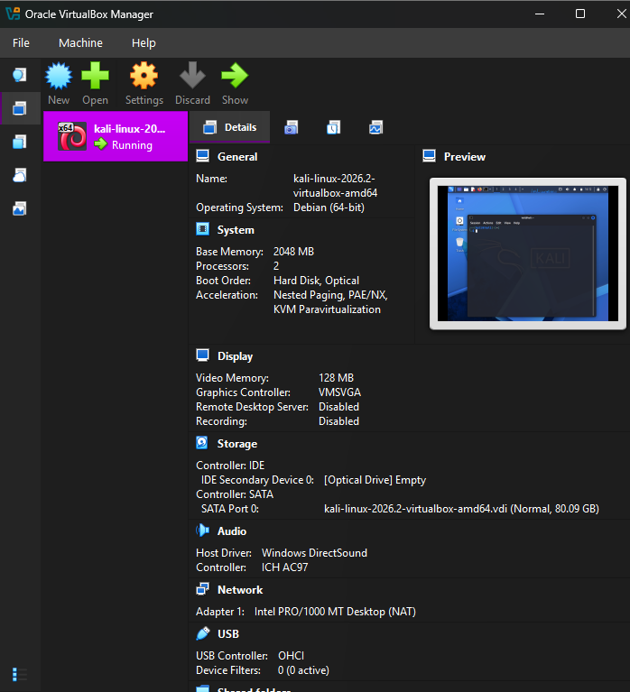

Step2: Logging into the Kali Linux VM
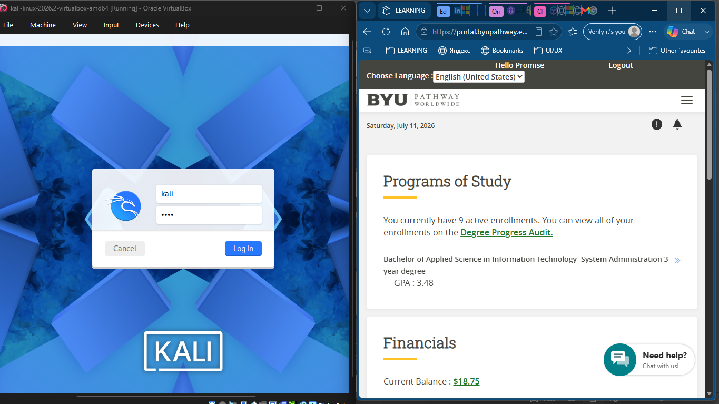

Steps 3 and 4

Step 3: Opening a terminal window
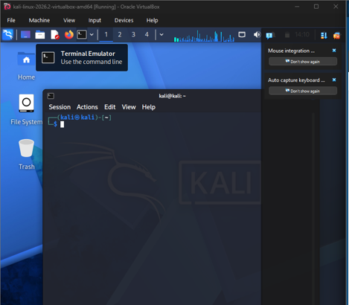

Step 4: Set up the python virtual environment

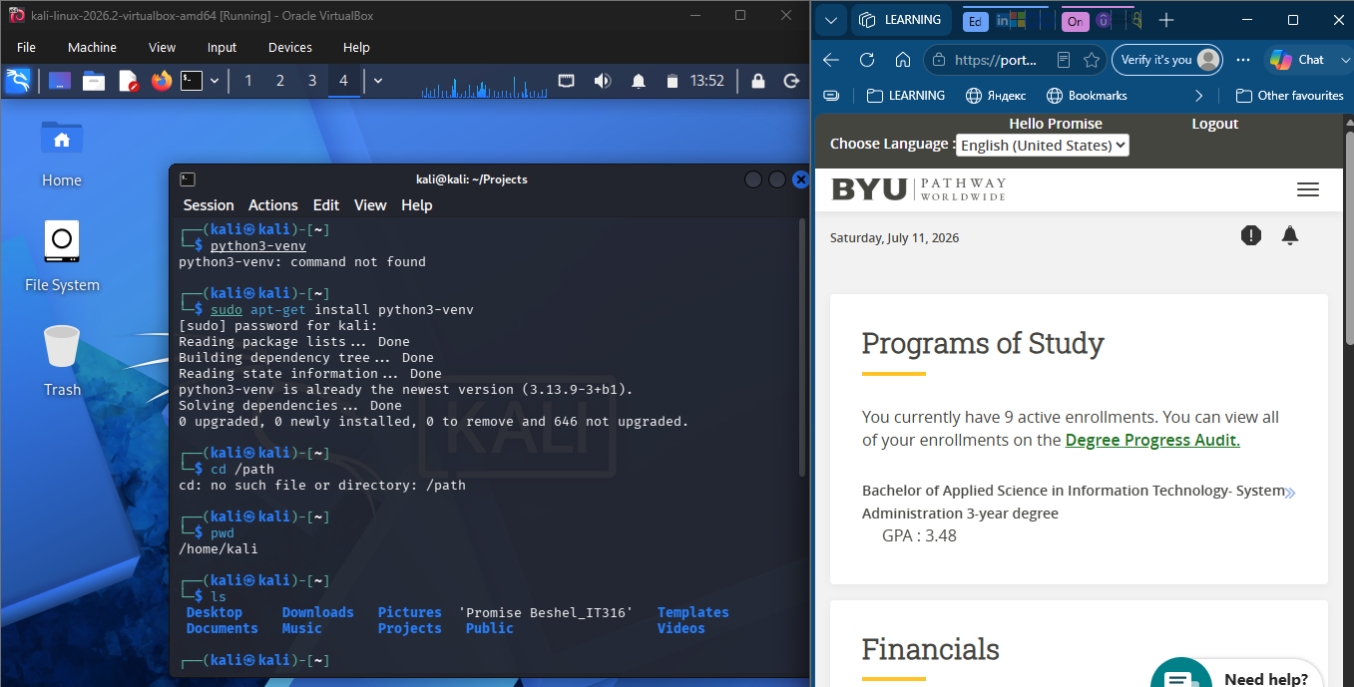

Step 5: Deactivating the python virtual environment
